ONGC’s INSIGHT DASHBOARD REQUIREMENTS DESCRIPTION

Contents
Insight Dashboard Overview 3
Milestones tracked 3
Manual Data Tracking 4
Filters available in the dashboard 4
Dashboard View of Plots 6
Annexure-I 10
Approval Date Columns Mapping 10
Common Approval Lookup Flow 11
Report Created Column Mapping 11
Report Created Lookup Flow 11

Insight Dashboard Overview
This document presents a description of ONGC’s requirements to view progress of their well planning process in a dashboard.
ONGC wants to visualize the following DWP milestones using the dashboard:
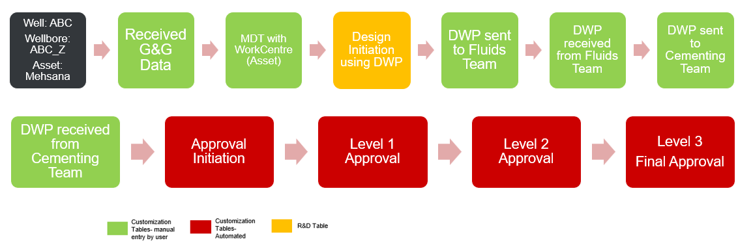

Milestones tracked
Each wellbore design is tracked through the following milestones, stored with a full date-and-time stamp:
1. Received G&G Data
2. Conduct MDT (with work centre / asset)
3. DWP sent to Fluids team (DFS)
4. DWP received from Fluids team (DFS)
5. DWP sent to Cementing team
6. DWP received from Cementing team
7. Design initiation
8. Approval initiation
9. Level-1 approval
10. Level-2 approval
11. Level-3 approval (final)

Standard wells track all 11 milestones. Well Montage designs only require 2 levels of approval, so they track 10 milestones and are considered complete once Level-2 approval is logged, Level-3 does not apply.
Completion rule: a well is marked Completed the moment its final approval level is logged (Level-3, or Level-2 for Well Montage) - even if an earlier step such as the Fluids-team or Cementing hand-off was never entered.

Manual Data Tracking
For tracking of most of these milestones, the plan is to build a customized component wherein users can manually enter the data for following milestones. This customized component will be made available at wellbore level and primary designs will be tracked. So, in case we have sidetracks, the same can be tracked in a similar manner.
- Received G&G Data
- Conduct MDT with work centre (different assets/ work locations of ONGC)
- DWP sent to Fluids Team
- DWP received from Fluids Team
- DWP sent to Cementing Team
- DWP received from Cementing Team
The above data shall be stored in Postgres dB table with timestamp (date & time).
Design Initiation using DWP:
This needs to be mapped with “Initiate” button of design at wellbore level and the timestamp of the same will be mapped.
Company, Project, Site, Well and Wellbore needs to be traced for particular design.
Approvals:
The approvals need to be tracked from approvals table. The timestamp will be tracked from customize approvals table. The mapping for approvals is available as Annexure in this document.

Filters available in the dashboard
The dashboard exposes the following filters:
- Asset name
- Date- Year, Month and Day selected together
- Status- Data received / In-progress / Completed
- User email
- Search well name
- Report approval stage- Initiated / Level-1 / Level-2 / Level-3
- Type of Reports- All / Montage only / Standard only
- Sort wells by- Longest duration, Alphabetical, or Most recent
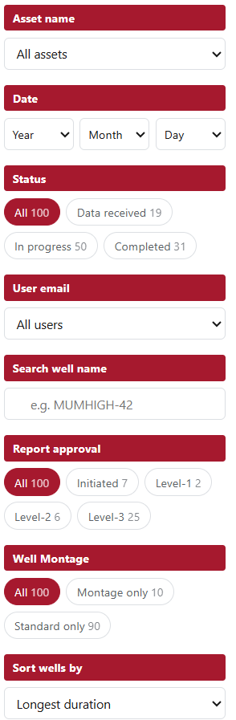

Dashboard View of Plots
- Wellbore Progress Timeline: This plot shall show number of days in x-axis and well & wellbore name on y-axis. The chart shall show all the milestones with different colours tracking number of days between each activity in pipeline. The same should be available in tabular form.
If any of the milestone is missing in between, it should skip the milestone and track data between available milestones
The plot can have an option to view as chart pr table. In chart, by default only top 10 wellbores should be visible, based on user preference of “Sort wells by” in filters. There should be an option to “show all” if possible. In table view, it shall show all the wells selected in the filter.

Chart:
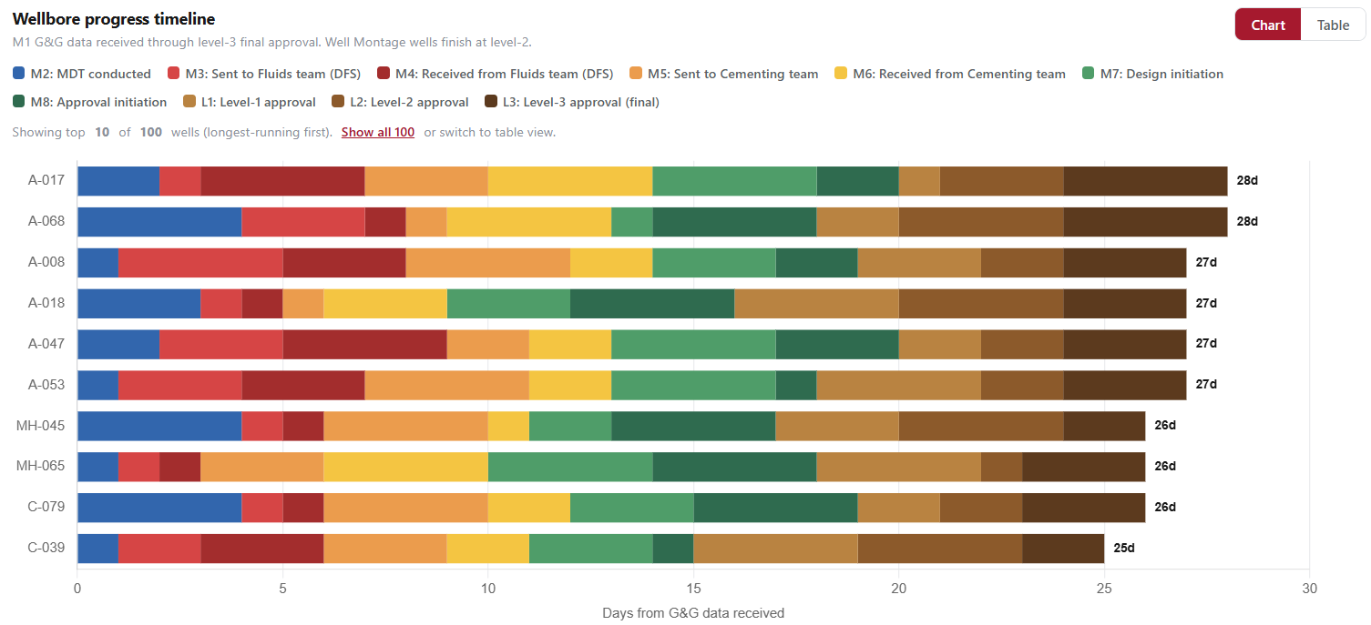
Table:
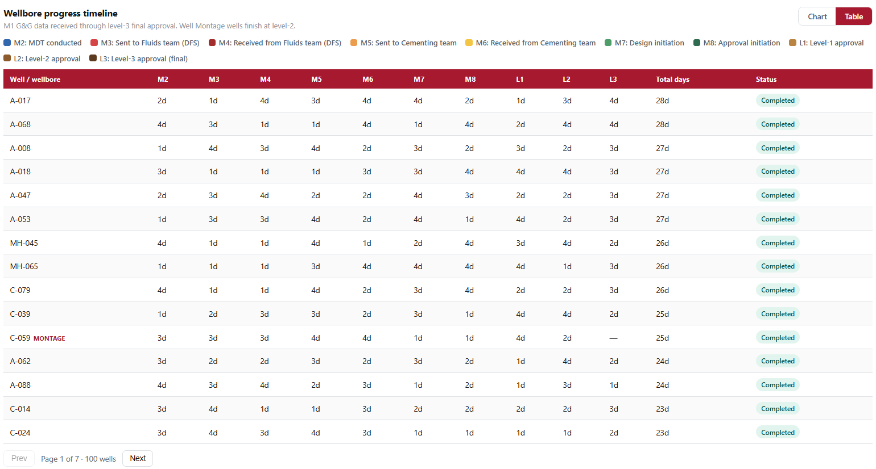
- Well Register: This table is a summarized version of each well progress (not mandatory, if can be fulfilled, Quarter can be skipped from this table). Date & Time should be picked up from start data of current milestone
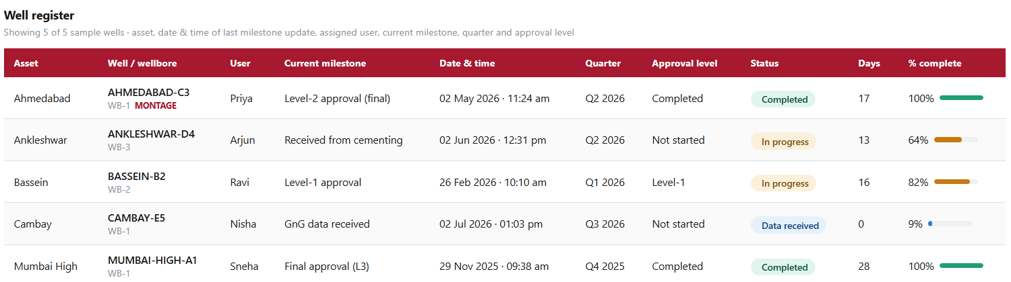
- Well Progress Timeline: This plot shall show total number of days it took to complete a particular wellbore. Bars can be of different colors for “Completed”, “In-progress” and “Data Received” wellbores

- Approval Level Tracking: This plot shall show approval progress of a wellbore taking initiation as day 0 and track 3 level of approvals from there. This plot shall have wellbore names on y-axis and number of days on x-axis.
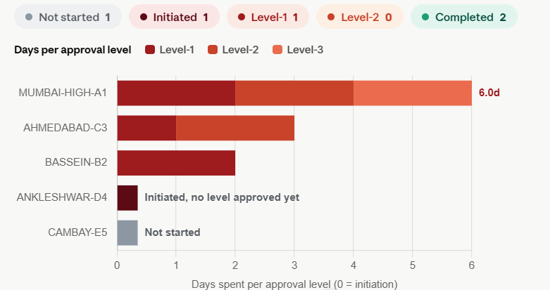
- Target vs Plan Wells: ONGC will be providing us with an excel sheet wherein they shall provide us with target wells planned for a financial year (March xxxx to March xxxx) against each asset. The plot should show comparison between “Target”, “Data Received”, “In-progress” and “Completed” wells against each asset by count of wells.
Data Received: this will be a manually entered date by user
In-progress: starting point should be the data received until final approval
Completed: final approval has taken place

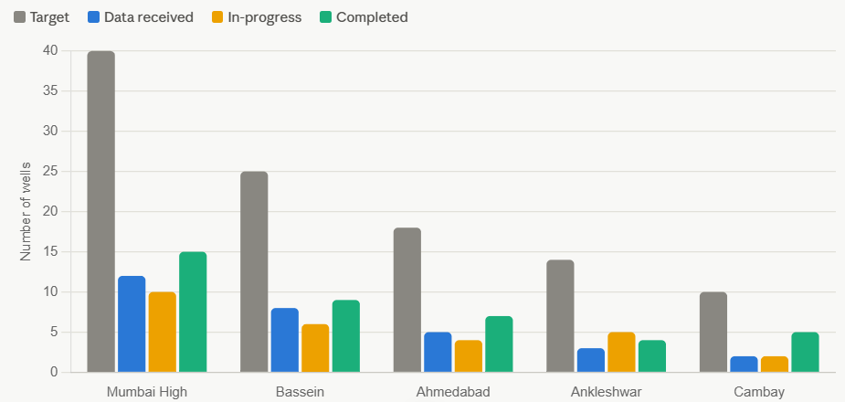

- ONGC follows a 3 level of approval process for wells wherein they generate detailed reports. They will be following 2 level of approval process for reports wherein only Well montage is used. For Well montage reports, we shall have only 2 level of approvals to mark it complete.
This can be tracked:
- Either the logic should be in-built such that if it does not find any level of approval beyond the ongoing approval level, it should consider that particular level as the final one
- In the customized component, we can provide an option for the user to tick if they will be generating Well montage for a particular well program and hence only 2 level of approvals to be tracked for that design

- Few cards can be incorporated into the dashboard if possible, to visually enhance the dashboards

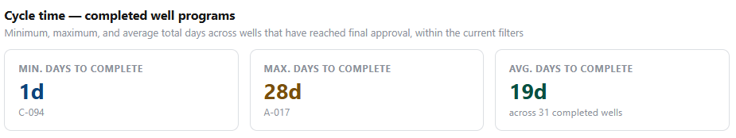

Annexure-I

Approval Date Columns Mapping
The following report columns are populated using approval workflow data retrieved from the approval-related tables.
Approval Initiation | Retrieve approval_id from dwp_gate_approval using report_id, phase_id, and wellbore_id. Using approval_id, retrieve revision_id from dwp_gate_approval_revision. Using revision_id, retrieve team_id from dwp_approval_team. Query dwp_approval_team_members for the corresponding team_id with level = -1 (Initiator) and status = 1 (Approved). Use the resulting approval_team_member_id to query dwp_signatory_data and display the date_time value.
Level 1 | Follow the same approval chain described above. In dwp_approval_team_members, filter by level = 1 and status = 1 (Approved). Use the resulting approval_team_member_id to retrieve the date_time from dwp_signatory_data.
Level 2 | Follow the same approval chain described above. In dwp_approval_team_members, filter by level = 2 and status = 1 (Approved). Use the resulting approval_team_member_id to retrieve the date_time from dwp_signatory_data.
Final Approval Level 3 | Follow the same approval chain described above. In dwp_approval_team_members, filter by level = 3 and status = 1 (Approved). Use the resulting approval_team_member_id to retrieve the date_time from dwp_signatory_data.

Common Approval Lookup Flow
- dwp_gate_approval → Get approval_id using report_id, phase_id, and wellbore_id.
- dwp_gate_approval_revision → Get revision_id using approval_id.
- dwp_approval_team → Get team_id using revision_id.
- dwp_approval_team_members → Get approval_team_member_id using:
  - team_id
  - Required approval level (-1, 1, 2, or 3)
  - status = 1 (Approved)
- dwp_signatory_data → Retrieve date_time using approval_team_member_id.
The date_time value from dwp_signatory_data is displayed in the corresponding report column.

Report Created Column Mapping
The following report column is populated using data retrieved from the custom report record and its associated report context.
Report Column | Data Source Logic
Report Created | Query the custom_report table using phase_id, well_id, design_id, and wellbore_id. If multiple records are returned, select the latest record based on the create_date column. From the selected record, retrieve the final_report_context array. Although the array is expected to contain a single object, as a safety measure select the object with the latest updateDate value. The selected object’s updateDate is displayed in the Report Created column.

Report Created Lookup Flow
- custom_report → Retrieve records using phase_id, well_id, design_id, and wellbore_id.
- Select the latest record based on the create_date column.
- Read the final_report_context array from the selected record.
- Select the object with the latest updateDate value from the array.
- Display the selected updateDate value in the Report Created column.
The updateDate value from the selected final_report_context object is displayed in the Report Created report column.

